Mathematical Theorem

🌟 Definition
# Source: AI Source: Provided by: [Data Path: Persons Table -> ID Column: 1, Name_En Column: Motasem Essam] -> From: [ChatGPT] on [5/29/2026]
A mathematical theorem is a statement that has been proven to be true using logical reasoning based on definitions, axioms, and previously established theorems.
Unlike an axiom, a theorem is not accepted without proof. Its truth must be demonstrated through a valid mathematical proof.

🎯 Purpose of Mathematical Theorems
# Source: AI Source: Provided by: [Data Path: Persons Table -> ID Column: 1, Name_En Column: Motasem Essam] -> From: [ChatGPT] on [5/29/2026]
- Establish proven mathematical truths
- Explain relationships between mathematical objects
- Build mathematical theories and knowledge
- Solve mathematical problems
- Serve as foundations for further theorems

📚 Characteristics of a Theorem
# Source: AI Source: Provided by: [Data Path: Persons Table -> ID Column: 1, Name_En Column: Motasem Essam] -> From: [ChatGPT] on [5/29/2026]
A mathematical theorem is:
- A statement or proposition
- Proven using logical reasoning
- Based on definitions and axioms
- Universally true within its mathematical system
- Often used to derive other results

🧩 Structure of a Theorem
# Source: AI Source: Provided by: [Data Path: Persons Table -> ID Column: 1, Name_En Column: Motasem Essam] -> From: [ChatGPT] on [5/29/2026]
A theorem generally contains:
1. Hypotheses (Assumptions)
The conditions that must be satisfied.
2. Conclusion
The result that is claimed to be true.
3. Proof
The logical argument showing that the conclusion follows from the assumptions.

✏️ Examples of Mathematical Theorems

Example 1: Pythagorean Theorem
# Source: AI Source: Provided by: [Data Path: Persons Table -> ID Column: 1, Name_En Column: Motasem Essam] -> From: [ChatGPT] on [5/29/2026]
In a right triangle:
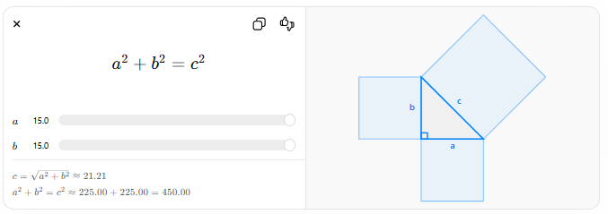
$$a^{2}+b^{2}=c^{2}$$
$$a$$
$$b$$
$$c=\sqrt{a^{2}+b^{2}}≈21.21$$
$$a^{2}+b^{2}=c^{2}≈225.00+225.00=450.00$$
The square of the hypotenuse equals the sum of the squares of the other two sides.

Example 2: Euclid's Theorem
# Source: AI Source: Provided by: [Data Path: Persons Table -> ID Column: 1, Name_En Column: Motasem Essam] -> From: [ChatGPT] on [5/29/2026]
There are infinitely many prime numbers.

Example 3: Fundamental Theorem of Arithmetic
# Source: AI Source: Provided by: [Data Path: Persons Table -> ID Column: 1, Name_En Column: Motasem Essam] -> From: [ChatGPT] on [5/29/2026]
Every integer greater than 1 can be expressed uniquely as a product of prime numbers.
Example:
60 = 2² × 3 × 5

Example 4: Fundamental Theorem of Calculus
# Source: AI Source: Provided by: [Data Path: Persons Table -> ID Column: 1, Name_En Column: Motasem Essam] -> From: [ChatGPT] on [5/29/2026]
Differentiation and integration are inverse processes.

🔗 Relationship to Other Mathematical Concepts
# Source: AI Source: Provided by: [Data Path: Persons Table -> ID Column: 1, Name_En Column: Motasem Essam] -> From: [ChatGPT] on [5/29/2026]
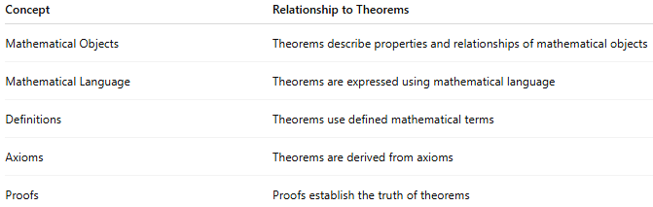
Concept | Relationship to Theorems
Mathematical Objects | Theorems describe properties and relationships of mathematical objects
Mathematical Language | Theorems are expressed using mathematical language
Definitions | Theorems use defined mathematical terms
Axioms | Theorems are derived from axioms
Proofs | Proofs establish the truth of theorems

📖 Definition vs. Axiom vs. Theorem
# Source: AI Source: Provided by: [Data Path: Persons Table -> ID Column: 1, Name_En Column: Motasem Essam] -> From: [ChatGPT] on [5/29/2026]
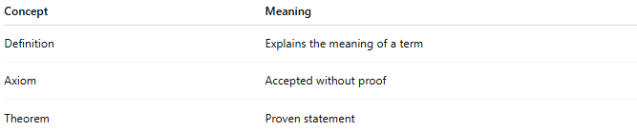
Concept | Meaning
Definition | Explains the meaning of a term
Axiom | Accepted without proof
Theorem | Proven statement
Example
Definition:
A prime number is a natural number greater than 1 with exactly two positive divisors.
Axiom:
Things equal to the same thing are equal to each other.
Theorem:
There are infinitely many prime numbers.

🏛 Related Terms
# Source: AI Source: Provided by: [Data Path: Persons Table -> ID Column: 1, Name_En Column: Motasem Essam] -> From: [ChatGPT] on [5/29/2026]

Term | Meaning
Lemma | A helper theorem used in proving another theorem
Corollary | A result that follows directly from a theorem
Proposition | A proven statement, often less central than a theorem
Conjecture | A statement believed to be true but not yet proven

🧭 Summary
# Source: AI Source: Provided by: [Data Path: Persons Table -> ID Column: 1, Name_En Column: Motasem Essam] -> From: [ChatGPT] on [5/29/2026]
A mathematical theorem is a statement that has been proven true through logical reasoning using definitions, axioms, and previously established results. Theorems are among the most important products of mathematics because they reveal proven truths about mathematical objects and their relationships.

